APPENDIX D: VOICE-CONTROLLED WEB BROWSING FOR THE ELDERLY – APPLICATION OVERVIEW

Kirti Nathoo

School of Electrical & Information Engineering, University of the Witwatersrand, Private Bag 3, 2050, Johannesburg, South Africa

# Introduction

The application is decomposed into three fundamental components: visual rendering, voice recognition and navigation. Visual rendering refers to the application Graphical User Interface (GUI) through which users interact. The voice recognition component is incorporated into the application GUI. Navigation links the two components to enable users to browse the web using voice commands. The application is structured according to a three-tier architecture model composed of three layers: presentation, business and data. The Rapid Application Development (RAD) life cycle method has been followed and iteration requirements have been prioritised.

# VISUAL RENDERING

The application GUI is specifically designed for elderly users. Settings such as font size and colour have been explicitly adapted for the usability and preference for the elderly. The page layout is structured to reduce confusion and cluttering for computer illiterate users. These aspects have been developed through the use of HyperText Markup Language (HTML) and Cascading Style Sheets (CSS) components.

## Iteration 1

A simple website has been designed for iteration one. The website consists of a series of web pages which are divided into five main sections: numerical, link name, visual feedback and verbal feedback. The visual feedback section is further divided into a pop up and link highlighting section. Web pages for each section are stored in separate folders to eliminate confusion and volume of HTML files. The numerical referencing section has been tested first and consists of five questions. The same five questions are applied to the link name referencing section which has been tested after. To answer a particular question, first the correct category must be selected as shown for numerical referencing in the screenshot shown in figure 1. Thereafter the correct fact is selected by saying the associated fact number as shown in figure 2.

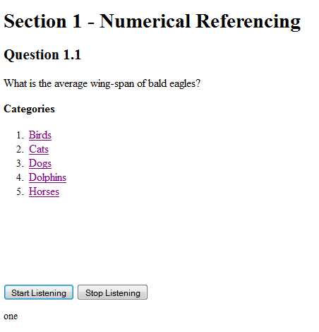

Figure 1: Selecting a category by saying the associated number

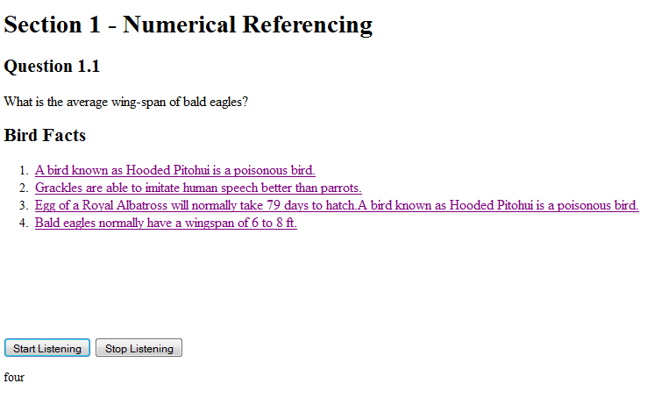

Figure 2: Selecting a fact by saying the associated fact number

The same approach is applied to the link name referencing section. However, in this section a category is selected by saying the text highlighted in green as illustrated in figure 3. To select the correct fact the text highlighted in the sentence must be spoken as shown in figure 4.

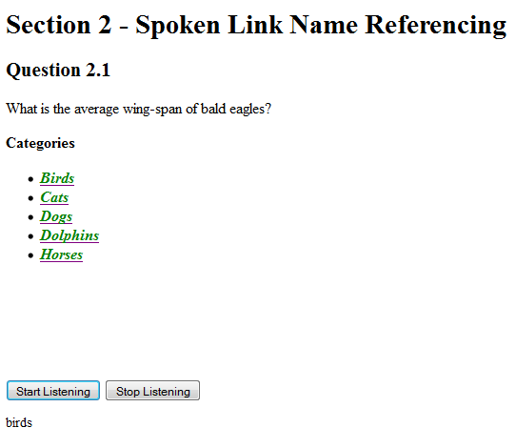

Figure 3: Selecting a category by saying the text highlighted in green

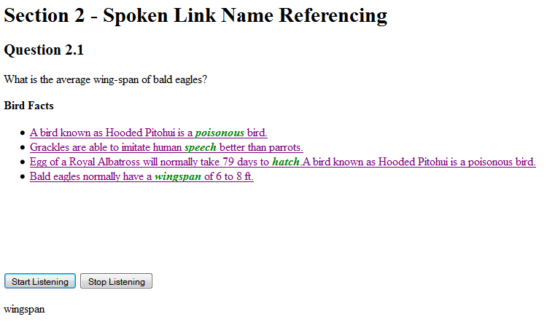

Figure 4: Choose the correct fact by saying the text highlighted in green

For the remaining sections, the same two questions are applied to each section. Numerical referencing is used as a referencing technique in these sections for simplicity purposes. The first subsection in the visual feedback section is pop ups. A pop up is displayed to the user each time an answer is provided. The pop up displays the answer the user entered for both category and fact selection. A category answer pop up is shown in figure 5. Link highlighting is the other visual feedback method used to provide users with feedback when a particular link is selected. When a link is selected the colour of the link changes to red as shown in figure 6.

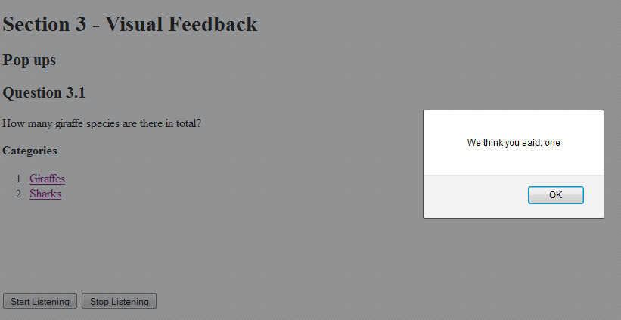

Figure 5: Pop up indicating which category has been selected

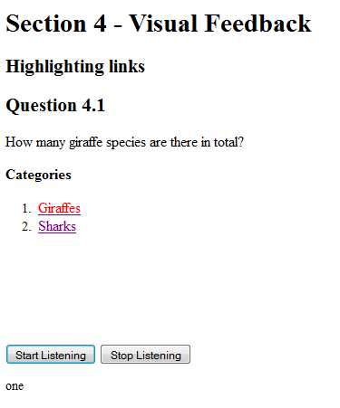

Figure 6: The link changes colour to red upon selection

The final section is the verbal feedback section. Each time the users provides an answer the application verbally repeats the answer back to the user. This feedback can be heard through the speaker output of a PC or by using headphones.

## Iteration 2

Iteration two encompasses the same design as the first iteration. However in this instance all the feedback sections have been removed.

## Iteration 3

A facsimile of a local news website has been designed for iteration three. Components of the web page have been grouped and positioned using divisions (divs) and CSS properties. The top section of the website consists of a menu header. The menu header displays the current date and time using JavaScript functionality. A logo and adverts are included in the header as shown in figure 7. Thereafter top stories are grouped together in a top story division.



Figure 7: Menu header and top story section of news website facsimile

The website consists of four main sections: South Africa, Sport, World and Entertainment. Each section displays a top story and related article links are listed below as shown in figure 8.

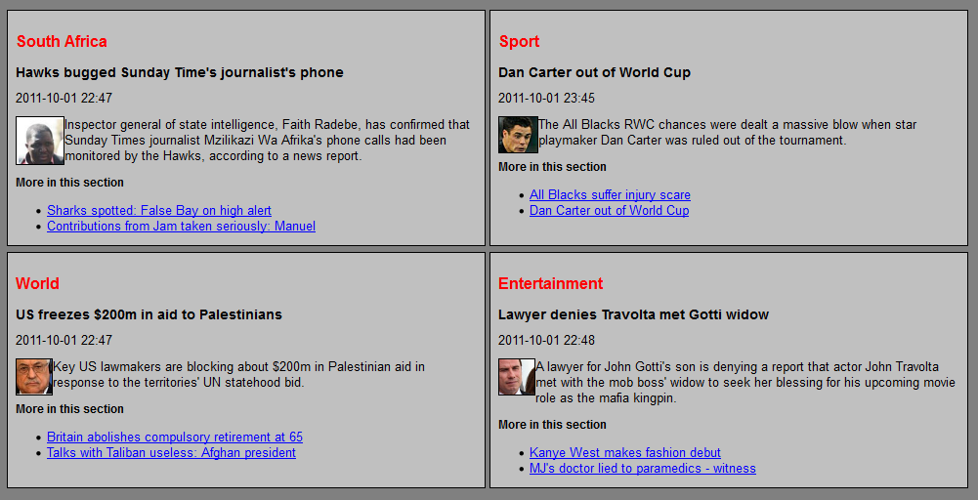

Figure 8: Four news sections within the website

Two versions of the website have been created in order to test the different referencing techniques. For the first version, numerical referencing is applied as seen in figure 9. Article links are indicated in blue and are accessed by the saying the associated number. Similarly spoken link referencing has been applied to the second version of the website as shown in figure 10. In this version article links are accessed by saying the text highlighted in green within the link.

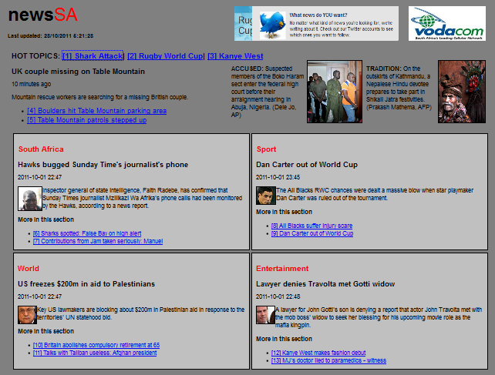

Figure 9: Complete home web page layout for numerical referencing

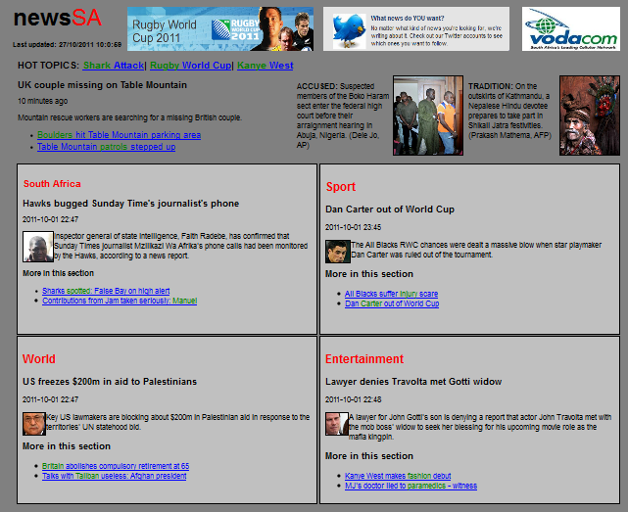

Figure 10: Web page layout for link name referencing

When an article is selected the colour of the link changes to red as shown in figure 11. For example, in the numerical referencing section if the user wants to read the article on the All Blacks in the Sport section, the user is required to say the number “eight.” Thereafter the article link is highlighted to show that it has been selected. Users are then required to confirm that they wish to read the article by saying “yes.” Upon the link being highlighted, the voice command input is repeated back to the user. These feedback methods have been applied to both referencing website versions.

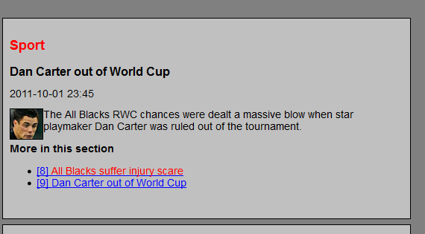

Figure 11: Link colour highlighting when a link is selected

When an article link is selected the browser is instructed to navigate into the corresponding section. In this instance the browser navigates into the Sport section. The Sport section further contains an article on the home page. To continue browsing to the article on the All Blacks the corresponding number must be selected again as shown in figure 12.

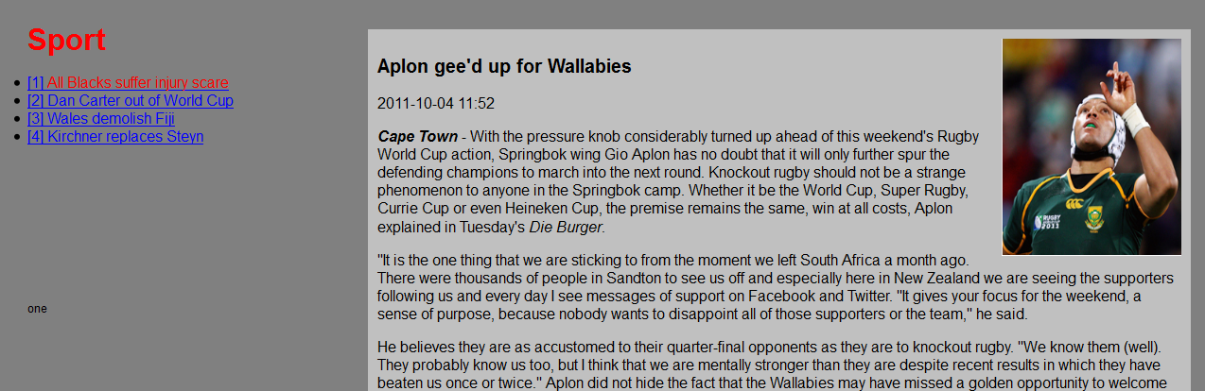

Figure 12: Article one is selected in the numerically referenced Sport section

The same concept is applied to the link name referencing website. To select an article the text highlighted in green must be spoken as shown in figure 13.

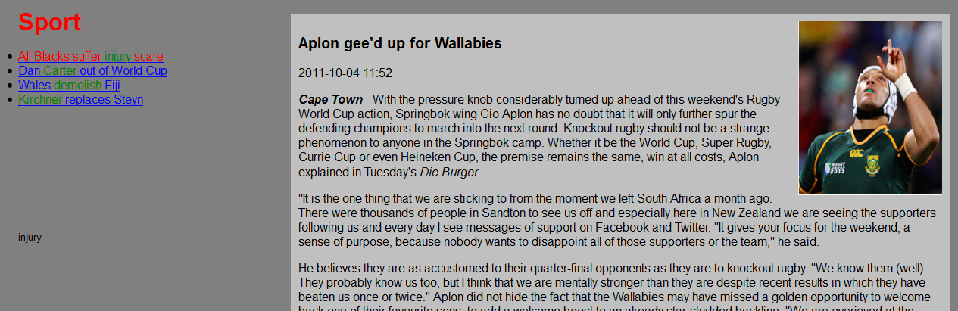

Figure 13: The All Blacks article is selected in for link name referencing

Additional navigation commands such as up, down, home and backwards have been incorporated into the web application. These commands are repeated back to the user and require confirmation before execution.

# ARCHITECTURE

The visual rendering, voice recognition and navigation components are categorised according to a three-tier architecture model shown in figure 14. The model illustrates different clients which communicate with the application. The clients interact with the application through the presentation layer. The business layer links the presentation and data layer.

Client

Presentation layer

Client

Business layer

Data layer

Application

Presentation layer

Figure 14: Three-tier architecture model

# SOFTWARE LIFE CYCLE

The RAD software life cycle method has been followed. RAD defines and prioritises requirements according to the MoSCoW acronym denoted by:

* Must haves: these are requirements that are definitely needed.
* Should haves: requirements that are important but not essential for the development of a usable system.
* Could haves: are requirements which are only implemented if additional time is available.
* Won’t haves: these are requirements which will be left for the next iteration.

RAD employs a time box concept. A time box consists of a fixed time frame within which certain activities are performed. The time box is decided upon first and thereafter the project attempts to fulfil the requirements within the time frame. If all the functionality is not implemented within the time frame, certain functionalities are sacrificed. The functionality requirements are grouped into iterations to ensure fundamental requirements are primarily met [1]. Three iterations have been defined for application developments and the key requirements of each iteration are listed.

Iteration 1:

* Determine the performance between numerical and link name referencing techniques for simple websites.
* Determine which visual feedback techniques – pop ups or link highlighting – are preferred by users.
* Ascertain if users would like verbal feedback whilst using the application.

Iteration 2:

* Investigate the performance of numerical and link name referencing techniques for simple web pages.
* Include a tutorial before each section and determine if this is beneficial to users and differs from results previously obtained in iteration one.
* Remove feedback techniques which have been previously tested.
* Ascertain if users prefer saying a particular word, part of or the complete sentence for the link name referencing technique.

Iteration 3:

* Determine the performance of numerical and link name referencing styles on complex websites.
* Determine which technique users prefer.
* Ascertain if users think it’s reasonable to expect elderly users to press a button to activate voice recognition each time they speak.
* Establish if users like verbal feedback.
* Determine the necessity of user confirmation.
* Determine if users would prefer a non-internet based application.

# CONCLUSION

Respective application GUIs have been designed for each iteration. Each web page has been specifically designed and structured to increase the usability of web browsing for the elderly. Screenshots of web pages and navigation functionalities within the web application have been provided. The web application has been structured according to a three-tier architecture model. The RAD life cycle has been followed and the web application has been decomposed into three iterations. Requirements for each iteration have been prioritised and listed.

# references

[1]. Vliet H V. *Software Engineering Principles and Practice*. John Wiley & Sons, Ltd, England, third edition, 2008, pp

62-64.